2 runs shown below obtained with: (n_timesteps, delta, c) = (2million, 0.01,0.01)

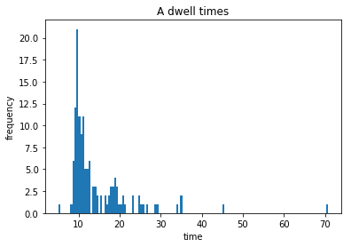

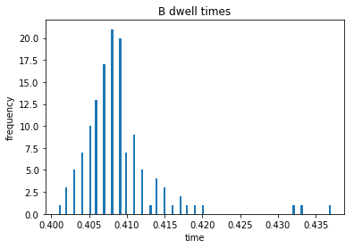

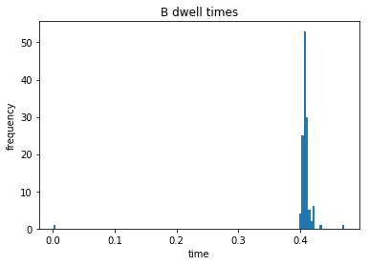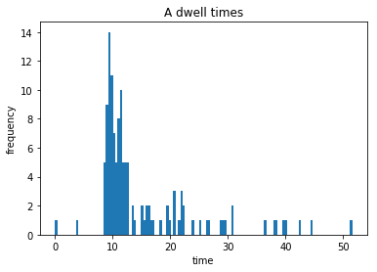

- does the specific ‘switch’ Boolean which detects transitions influence these outputs– how can we more precisely detect switches (-0.8 obtained visually – not a lot of confidence in this)

- how do the parameters influence the output? Continue to play with them.

- Can we make the function more efficient? It takes very long to run!

To do:

- gather data for long period of time

- identify if the tail is exponential or algebraic